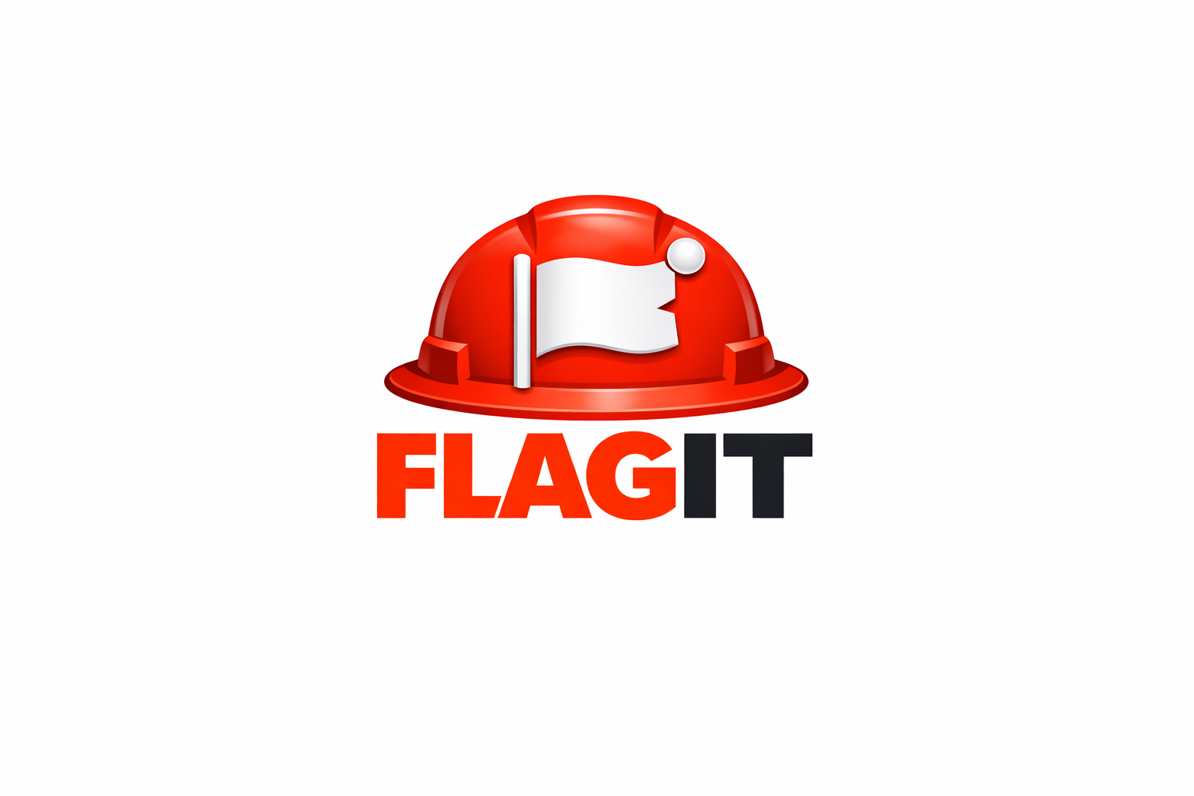
HSE Observation Platform
Security, Data Storage & Privacy Statement
April 1, 2026
TABLE OF CONTENTS

1. About FLAGIT 2
2. Where Is Your Data Stored? 2
Cloud Infrastructure 2
Data Centres 3
Backups 3
File Storage (Photos) 3
3. Security Architecture 3
Authentication 3
Invite-Only Access 3
Role-Based Access Control (RBAC) 4
Row-Level Security (RLS) 4
Data Isolation 4
Encryption 4
Infrastructure Security 4
4. Data Privacy 5
What Data We Collect 5
What We Do NOT Collect 5
Data Ownership 5
Data Retention 5
GDPR Compliance 5
5. AI Features 6
6. Compliance & Standards 6
7. Incident Response 6
8. Availability & Uptime 6
9. Contact & Data Requests 7
10. Summary for Decision Makers 7

1. About FLAGIT
FLAGIT is a cloud-based HSE (Health, Safety & Environment) observation and compliance tracking platform designed for field officers, HSE managers, and site supervisors operating in construction, oil & gas, manufacturing, and industrial environments.
FLAGIT enables real-time observation reporting, corrective action tracking, NCR generation, and team collaboration — accessible from any device, anywhere on site.

2. Where Is Your Data Stored?

Cloud Infrastructure
All FLAGIT data is stored on Supabase, a world-class enterprise database platform built on PostgreSQL — the same database technology trusted by organisations including Apple, Instagram, and the International Space Station.

Data Centres
- Supabase operates on Amazon Web Services (AWS) infrastructure
- Data is hosted in highly available, redundant data centres
- Default region: US East (Virginia) — regional options available on request
- Data is replicated across multiple availability zones ensuring zero single point of failure

Backups
- Automatic daily backups are performed and retained for a minimum of 7 days
- Point-in-time recovery is available — data can be restored to any specific moment
- Backups are stored in geographically separate locations from primary data
- No data is ever permanently lost due to hardware failure

File Storage (Photos)
- Observation and close-out photos are stored in Supabase Storage
- All files are stored in private, access-controlled buckets
- Photos are only accessible to authenticated members of the relevant project
- Files are encrypted at rest and in transit

3. Security Architecture

Authentication
- FLAGIT uses email-based One-Time Password (OTP) authentication
- No passwords are stored — eliminating password breach risks entirely
- Every login requires a fresh 6-digit code sent to the user's verified email
- Sessions are managed with industry-standard JWT (JSON Web Tokens) with automatic refresh and expiry

Invite-Only Access
- FLAGIT operates an invite-only access model
- No user can self-register and access project data without explicit approval from a project administrator
- Each invite is tied to a specific email address and project
- Invites expire and can be revoked instantly by administrators

Role-Based Access Control (RBAC)
FLAGIT enforces strict role-based permissions at every level:
Role | Capabilities
Admin | Full access — create, edit, delete observations, manage team members, send invites, revoke access
Member | Create and edit own observations, add comments, update status, view all project observations

Row-Level Security (RLS)
- Every database table is protected by Supabase Row-Level Security policies
- These policies are enforced at the database level — not just the application level
- Even if the application code were compromised, the database would still enforce access rules
- No user can ever access data from another organisation's project

Data Isolation
- Each organisation's data is completely isolated at the database level
- Project A cannot see, access, or query any data belonging to Project B
- This isolation is enforced by cryptographic user identity (UUID) — not just application logic

Encryption
- All data in transit is encrypted using TLS 1.2 / TLS 1.3 (HTTPS)
- All data at rest is encrypted using AES-256 encryption
- SSL certificates are issued and automatically renewed by Let's Encrypt
- The FLAGIT domain (getflagit.com) enforces HTTPS-only access — HTTP connections are automatically redirected

Infrastructure Security
- FLAGIT is hosted on Vercel — a SOC 2 Type II certified platform
- Vercel operates a global edge network with DDoS protection built in
- No direct database access is exposed to the public internet
- All API keys and credentials are stored as environment variables — never in source code

4. Data Privacy

What Data We Collect
FLAGIT collects only the minimum data necessary to operate the platform:
- Account data: Full name, email address, job role
- Observation data: Category, location, description, photos, timestamps, recommendations
- Activity data: Login timestamps, observation status updates, comments
- Presence data: Online/offline status (stored temporarily, not used for tracking)

What We Do NOT Collect
- No payment card information
- No biometric data
- No location/GPS tracking
- No device identifiers beyond what the browser provides
- No data is sold or shared with third parties for advertising purposes

Data Ownership
- Your organisation owns your data — at all times
- FLAGIT does not claim ownership of any observation data, photos, or reports generated on the platform
- Data export is available on request

Data Retention
- Active project data is retained for the duration of the subscription
- Upon account closure, data is retained for 30 days before permanent deletion
- Users may request immediate deletion of their data at any time

GDPR Compliance
FLAGIT is designed with GDPR principles in mind:
- Lawful basis: Data is processed only to deliver the contracted service
- Data minimisation: Only necessary data is collected
- Right to access: Users can request a copy of their data at any time
- Right to erasure: Users can request deletion of their personal data
- Data portability: Observation data can be exported in standard formats

5. AI Features
FLAGIT includes an optional AI-powered recommendation feature (Ask FLAGIT AI) that suggests corrective actions based on observation details.
- AI suggestions are powered by Groq using the LLaMA 3 language model
- No observation data is stored or used for AI training by the AI provider
- AI queries are stateless — each request is independent with no memory of previous queries
- Use of the AI feature is optional — all fields can be completed manually
- The AI API key is stored in the user's browser local storage only — never transmitted to FLAGIT servers

6. Compliance & Standards
FLAGIT's infrastructure providers maintain the following certifications:
Provider | Certifications
Supabase / AWS | SOC 2 Type II, ISO 27001, ISO 27017, ISO 27018, GDPR compliant
Vercel | SOC 2 Type II, GDPR compliant
Groq (AI) | SOC 2 Type II

7. Incident Response
In the event of a security incident:
- Affected organisations will be notified within 72 hours of discovery
- A full incident report will be provided including scope, impact, and remediation steps
- FLAGIT maintains an incident response plan aligned with ISO 27035 guidelines

8. Availability & Uptime
- FLAGIT targets 99.9% uptime for all production services
- Real-time status monitoring is in place for all critical components
- Supabase maintains a published status page at status.supabase.com
- Vercel maintains a published status page at www.vercel-status.com

9. Contact & Data Requests
For any security concerns, data access requests, or privacy enquiries:
FLAGIT Support 📧 support@getflagit.com 🌐 getflagit.com 📋 Data requests are acknowledged within 48 hours and fulfilled within 30 days

10. Summary for Decision Makers
Concern | FLAGIT Answer
Where is data stored? | AWS-backed Supabase cloud — enterprise grade
Is data backed up? | Yes — daily automatic backups with point-in-time recovery
Who can access our data? | Only invited members of your project — enforced at database level
Can other companies see our data? | No — complete cryptographic isolation between organisations
Is data encrypted? | Yes — AES-256 at rest, TLS 1.3 in transit
Is it GDPR compliant? | Yes — designed with GDPR principles
What if there's a breach? | 72-hour notification, full incident report
Do you sell our data? | Never
Who owns the data? | Your organisation — always

This document was prepared by FLAGIT and is accurate as of April 2026. For the most current version please visit getflagit.com or contact support@getflagit.com

